


PRODUCT DATASHEET
OUTDOOR LIGHTING | Outdoor Wall MOUNTED
Outdoor lighting | Wall mounted light |IP65
Code# OTWM20013-8
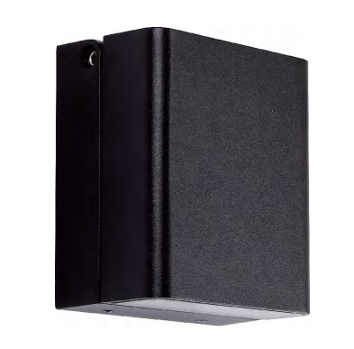

Areas of Application
- Courtyard
- Park
- Villa
- Corridor

Product Features
- IP65
- Aluminum Die-casting lamp body, Opal PC Diffuser,
- Powder coating White/Black optional
- High luminous efficacy, high CRI
- Anti-glare, without flicker
- Easy and quick installation

Complete Product Data

Code# OTWM20013-8
Wattage 8W
Installation Type Wall-Mounted
Dimension 105*120
Cutout /
IP Rating IP65
Luminous Flux /
Beam Angle Wide
Working Temperature -25℃ ~55℃
Certificates /
Warranty 3 Years
Packing Size /

Driver Data

Driver Brand Tridonic, Osram, Philips, Lifud, Euchips, Eaglerise, etc.
Input Voltage 100-250VAC 50/60hz
Output Voltage /
Output Current /
Power Factor >0.5 as standard; >0.9 optional
Efficiently 87% @230v
IP Rating IP20
Dimmable Non-Dimmable/Triac/0-10v/Dali Optional
Free Flicker Yes
Certificates CE, CB, CCC, ENEC
Warranty 3/5 Years

Material&Housing Data

Light Body Color White/Black
Reflector Color /
Light Body Material Die-casting Aluminum

Photometric Data

LED chip brand Cree/ Osram /Bridgelux/ Epistar etc.
Chip Type SMD
Color Temperature 2700K, 3000K, 4000K, 6000K
CRI >80
Life time >50000Hrs
Lumens efficacy 100-120lm/w

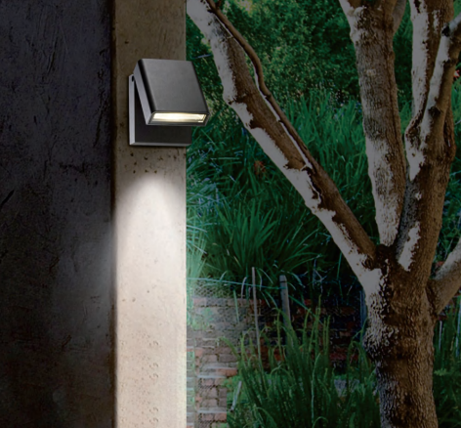
Dimensions&Installation

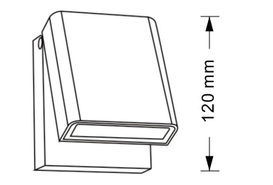

PLEASE FIND A QUALIFIED ELECTRICIAN FOR INSTALLATION. Please read the instructions before you install and use the outdoor wall-mounted light.
- Make sure the power is turned off in which you are installing the products.
- Fix the base with the screwdriver. (Fig 1)
- Connect the input terminal to the main power supply. (Fig2)
- Fix light body with tool. (Fig 3)
- Restore power at the source and the installation is complete.

